Lab 1 informatics screenshot. Akkushimov Viktor

A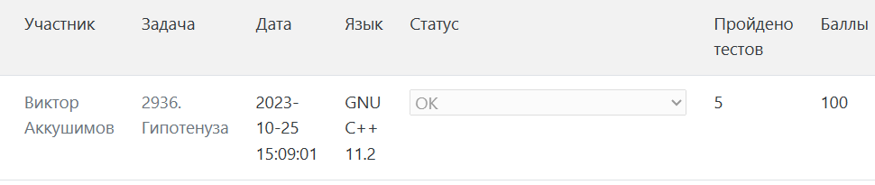

B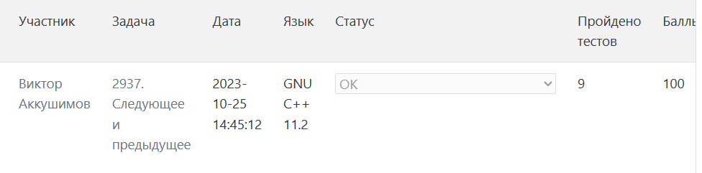

C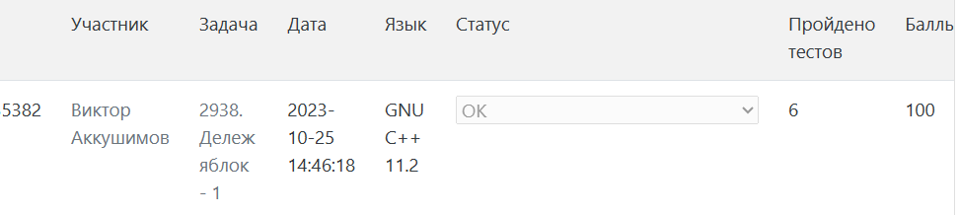

D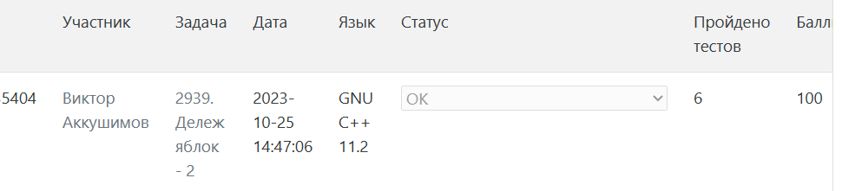

E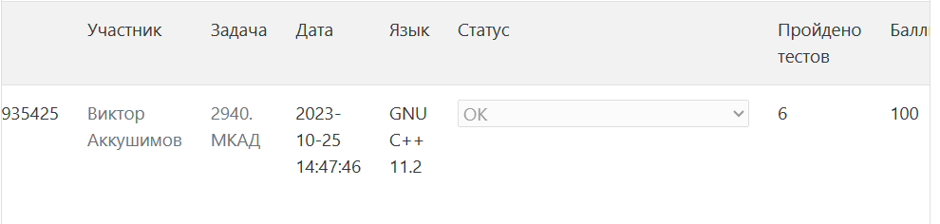

I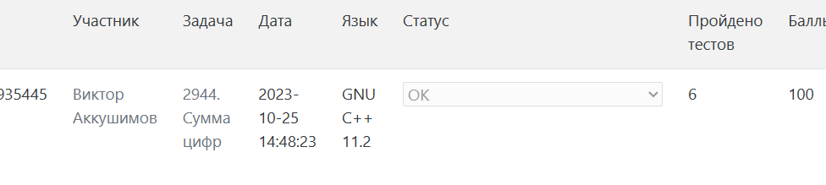

U